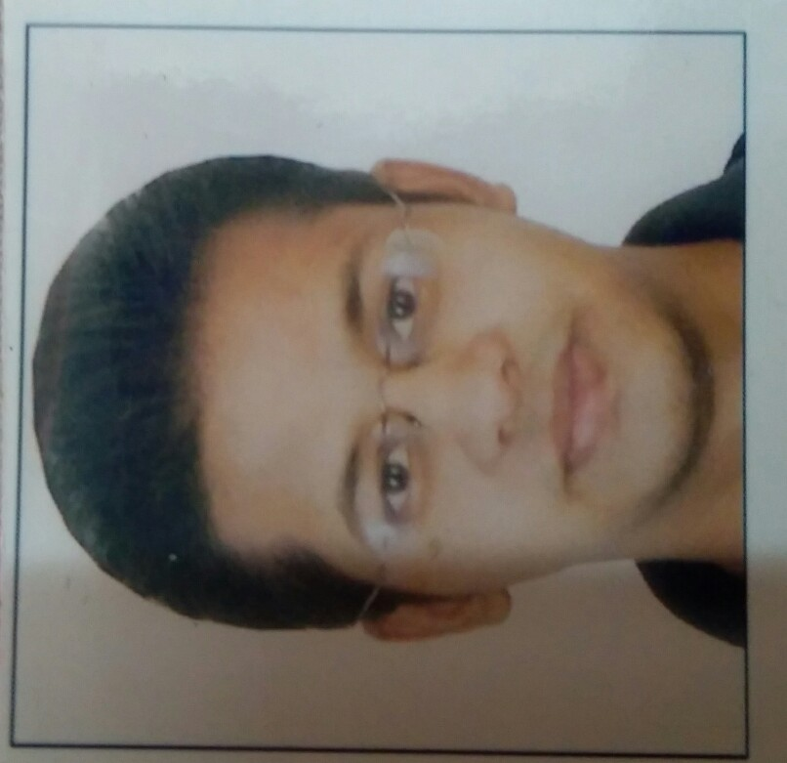

**CAREER OBJECTIVE –**

To serve the Humanity to the best of my ability.

To enhance my knowledge and capabilities by working in a dynamic organization that prides itself in giving substantial responsibilities to new talent.

**PERSONAL INFORMATION -**

Full Name – **Dr.SIDDHESH RAJENDRA SALVI.**

Date of birth – 7/12/1987

Address – Shardashram I/8,

Bhawani Shankar Road,

Dadar(W), Mumbai – 400028.

NATIONALITY – INDIAN.

Marital status - Single

**HIGHLIGHTS –**

* **Successfully Completed More than 900 Phaco. Surgeries including around 200 Topical Phaco. Surgeries With all official Surgical Records.**
* Also Performed **More than 600 Manual Small Incision Cataract Surgeries.**
* Successfully completed **Long Term Fellowship ( 2 Years ) in Phacoemulsification Cataract surgery, IOL Technique and Glaucoma management in Lions NAB Eye hospital.**
* Strong **Analytical Skills** in diagnosing ophthalmic diseases.
* **Fellowship trained Cataract Surgeon under Dr. Suhas Haldipurkar's Laxmi Eye Institute.** (Trained under Dr. Suhas Haldipurkar and Dr. Hetal Shah - Arvind eye institute.)
* **Excellent Communication Skills and Good Team leader.**

**BASIC ACADEMIC CREDENTIALS** –

MBBS - 2006

MS - OPHTHALMOLOGY – 2014.

Long Term Fellowship (2 Years) in Phacoemulsification Cataract Surgeries in Lions NAB Eye Hospital.

**SURGICAL EXPERIENCE -**

* **Assisted and trained under Dr. Milind Sabnis for more than 3000 cataract surgeries.**
* **Individually Operated More than 900 Successful Phacoemulsification Cataract Surgeries with all Official Surgical Records.**
* **Performed on various Phaco. Machines like Infinity(Alcon) , Lauret(Alcon) , Urteli , Chakshu and AMO.**
* **Performed more than 600 Manual Small Incision Cataract Surgeries.**
* **Completed around 200 Pterygium surgeries with autografting.**
* **Completed many minor Surgical procedures including Chalazion, corneal tear repair and conjunctival suturing.**

|  |  |
| --- | --- |
| **SURGERY NAME** | **SURGERIES PERFORMED** |
| **PHACOEMULSIFICATION CATARACT SURGERY** | **MORE THAN 900** |
| **MANUAL SMALL INCISION CATARACT SURGERY** | **MORE THAN 600** |
| **TOPICAL PHACO. SURGERY** | **AROUND 200** |
| **PTERYGIUM WITH AUTOGRAFT** | **AROUND 200** |
| **MINOR SURGICAL PROCEDURES** | **MORE THAN 150** |

**Anterior segment and Medical retina diagnosing Skills -**

* **Used to see patients on daily basis by using Indirect and direct ophthalmoscope.**
* **Excellent in Anterior segment evaluation by using Slit - lamp biomicroscope.**
* **Equipments - Used to work on recent Ophthalmology equipments on daily basis like,**

**A- scan**

**Contact and Non- contact tonometry**

**Perimetry**

**Streak Retinoscopy**

**Slit - lamp biomicroscopy with 90D.**

**Direct and Indirect ophthalmoscope**

**Pachymetry**

* **Assisted many laser procedures for Diabetic retinopathy patients under**

**Dr. C. Khare ( Vitreo-retina Surgeon )**

**PUBLICATIONS** -

* **International Journal of Scientific Research**-

Case report of Sebaceous Gland(Meibomian Gland) Carcinoma over left lower eye lid.

* **Indian Journal of Applied Research** -

Study of Incidence and Risk factors of PCO after manual SICS.

* **Global Journal for Research Analysis** -

Ocular manifestations in Leprosy patients.

* Very rare case of Trichoepithelioma over Right upper eye lid - **IJCR**.

I also done **presentations in various CME's** during my post graduation.

**RESEARCH PROJECT -**

* Study of Incidence and Risk factors of Posterior Capsular Opacification after Manual Small Incision Cataract Surgery.
* Study of Dry eye in undiagnosed Indian population.

( Dry eye tip of iceberg? )

(Published in **International Journal of Advanced Research**)

**EXPERIENCE –**

* 2 years of Long Term Fellowship in Phacoemulsification Cataract Surgery in Lions NAB Eye Hospital.
* 3 years as a Resident doctor in Ophthalmology department of Padmashree Dr. patil medical Hospital and Research centre, Maharashtra.
* Fellowship trained cataract surgery in Dr. Suhas Haldipurkar's Laxmi Eye Institute.

**Conferences attended in last 4 years** -

* MOSCON 2016
* BOA 2016
* BOA 2017
* DOSCON 2016
* BOA 2018
* BOA 2019

**Membership in Scientific Society** -

* All India Ophthalmological Society (AIOS)
* Bombay Ophthalmological Society (BOA)

**HOBBIES** -

Serving for Needy Peoples.

To play Cricket.

**LANGUAGES -**

English, Marathi and Hindi.